

GATE 0 – PROBLEM FORMULATION

Evidence Document
---------------------------------------------------------------------------------------------------------
Project: Tourist Place Search and Ranking System

Submitted by:
D - division

TEAM MEMBERS:
SRI GOURI [01FE22BCA195]
VAISHNAVI [01FE22BCA216]
HARSHITA S HEGDE [01FE22BCA232]
SANJOTA B NESARAGI [01FE22BCA239]

Under the Guidance of:
Ms. Rashmi Hiremath
Ms. Neha Banahattimath

DEPARTMENT OF COMPUTER APPLICATION
KLE TECHNOLOGICAL UNIVERSITY
The academic year 2026 - 27
Purpose of this Document
This document organizes the Gate 0 – Problem Formulation evidence for the Tourist Place Search and Ranking System. It covers A1 (problem statement and stakeholders), A2 (AS-IS and TO-BE workflows), A3 (scope, exclusions, feasibility and risks), A4 (Integration Map v1), and B1 (theme-specific governing rule and the record at risk of being decided incorrectly).
Project boundary used in this document: the system searches tourist places, presents destination information, records visits and feedback, calculates performance scores, ranks and compares places, and supports user profiles, favourites, search history and administration. Travel services, vehicle recommendations, riding-gear providers, booking/payment, chatbot, AI/ML predictions and GPS-based visit verification are not treated as core implemented modules. Safety can remain a feedback factor or destination detail only if the project team chooses to include it; it is not a separate module.

A1. Problem Statement and Stakeholders
A1.1 Problem Statement
People planning a visit to a tourist destination may need to search across different sources to find places that match their location and interests. Information can be difficult to compare consistently, and a place’s popularity or a single review may not represent the experience of multiple visitors. Without a consistent way to collect feedback and compare destinations, users may find it difficult to identify places that perform well across practical factors such as overall experience, cleanliness, facilities, accessibility and activities.
The Tourist Place Search and Ranking System addresses this problem by allowing users to search by location and category, view destination information, mark places as visited, and submit structured feedback. The system aggregates feedback from multiple users, calculates a performance score for each place, and ranks places using those scores. Users can then compare places and make a more informed selection. Administrators maintain place information, categories, reviews and relevant system data.

A1.2 Who Is Affected and How
Stakeholder | Need / concern | How the problem affects them
Tourists / users | Find suitable destinations and compare them fairly. | May spend extra time checking multiple sources and may struggle to judge places using consistent information.
Visitors submitting feedback | Share experience after a visit. | Their feedback may be scattered or difficult for future visitors to compare unless it is collected in a structured way.
Administrators | Keep place details, categories and feedback organized. | Manual or inconsistent records can become outdated, duplicated or difficult to maintain.
Project team / evaluators | Demonstrate a clear, testable search-and-ranking process. | An unclear ranking rule makes results difficult to explain, verify and test.

A1.3 Problem Goal
To build a web-based system that helps users search, explore, compare and rank tourist places using structured visitor feedback and transparent performance scores, while providing basic user and administrator management.

A1.4 Proposed Success Indicators
- A user can search for places by location and category and open a matching place’s details.
- A user can mark a place as visited and submit feedback through a structured form.
- The system calculates a score from the defined feedback factors and displays places in score-based order.
- A new valid review causes the relevant score and ranking to be recalculated or refreshed.
- An administrator can create, update or remove place information and manage categories and reviews.
- Users can access their favourites, search history and visited-place records.

A2. AS-IS and TO-BE Workflows

A2.1 AS-IS Workflow (Current / Problem Situation)
The AS-IS workflow describes the typical situation before the proposed system is available. It is a problem-context workflow, not a claim that every tourist follows exactly the same steps.
- A person decides to visit a tourist destination.
- The person searches different websites, social media posts, maps or recommendations.
- Place details and reviews appear in different formats and may not be directly comparable.
- The person manually compares ratings, descriptions, facilities and visitor comments.
- The person chooses a destination using the information they could find.
- After the visit, feedback may be posted on a separate platform or not recorded in a structured way.
- Future visitors may not see one consolidated performance score based on multiple visitors’ feedback.

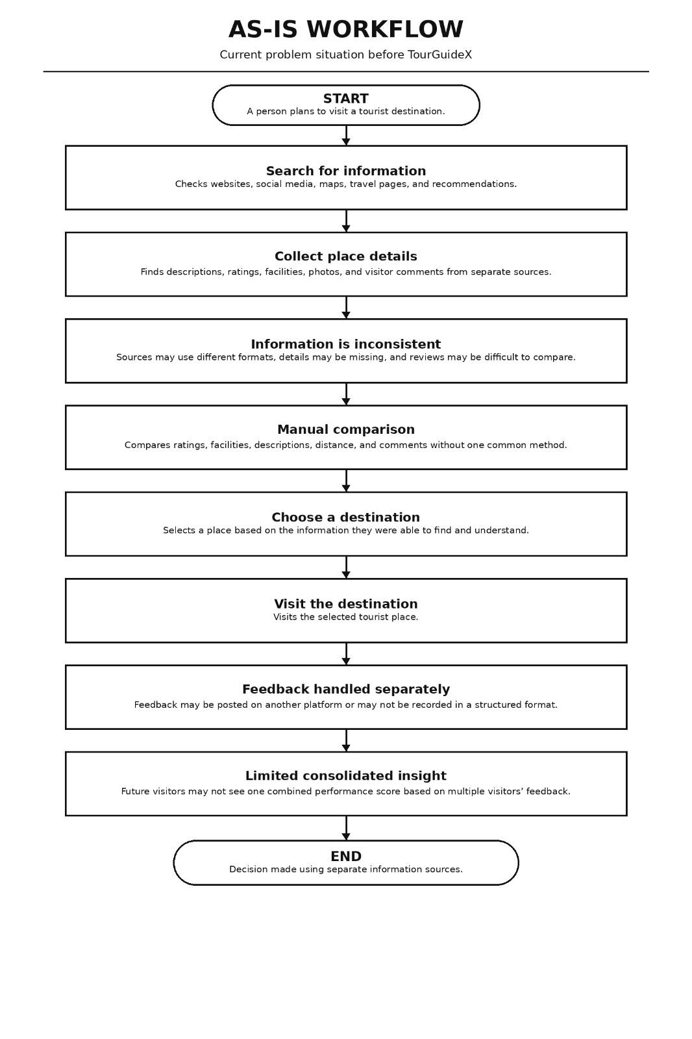

A2.2 TO-BE Workflow (Proposed System)
- The user opens TourGuideX and registers or logs in.
- The user searches by location and/or tourist-place category.
- The system displays matching places and their available details.
- The user opens place details and compares two to four places if desired.
- After visiting, the user marks the place as visited and submits structured ratings/review.
- The system validates and stores the feedback.
- The system aggregates valid feedback and calculates or updates the place’s performance score.
- The system sorts/ranks places by the defined score and displays ranking factors where available.
- The user views results and may save favourites or revisit search history and visited records.
- The administrator maintains place data, categories, reviews and other configured system information.

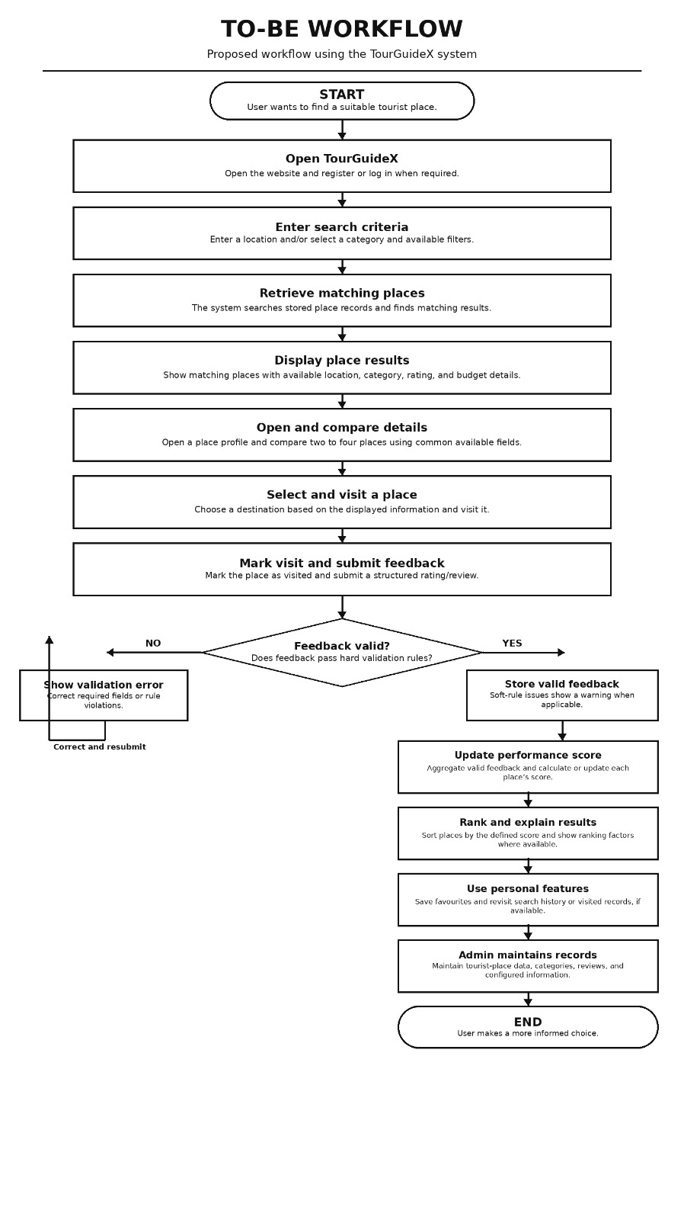

A2.3 Workflow Comparison
AS-IS | TO-BE
Information is checked across separate sources. | Place details are presented in one system where available.
Comparison is mostly manual. | Users can compare places using common fields and scores.
Reviews may be unstructured or scattered. | Feedback is collected in a structured format.
No project-defined consolidated score is guaranteed. | The system calculates scores using a declared rule.
Ranking may be subjective or inconsistent. | Ranking follows the system’s defined scoring and sorting rule.
Personal tracking may be separate or unavailable. | Favourites, search history and visited records are available to the user.

A3. Scope, Out-of-Scope, Feasibility and Risks

A3.1 In-Scope Features
- User registration, login/logout and profile management.
- Search tourist places by location and category.
- Display place information such as name, location, category, description, entry fee, timings, best time to visit, and selected details available in the database/API.
- Mark a place as visited and maintain visited-place records.
- Collect structured feedback and reviews based on the agreed rating factors.
- Calculate performance scores by aggregating valid user feedback.
- Rank places by score and refresh rankings when new valid feedback is saved.
- Compare two to four tourist places using available details and scores.
- Maintain favourites and search history.
- Admin management of tourist places, categories, users, feedback/reviews and ranking-related data.

A3.2 Out-of-Scope Features
- AI-based personalized recommendations.
- Machine-learning-based predictions or sentiment analysis.
- Chatbot functionality.
- Online booking and payment processing.
- Large-scale real-time navigation or route tracking.
- GPS-based or physical verification of tourist visits.
- A separate travel/safety/riding-support module, vehicle recommendations or riding-gear-provider management.
- Boundary note: safety may be included as one feedback factor or as a place-information field if approved by the project team, but it should not be represented as a separate module. The same scope boundary should be reflected in the synopsis, architecture diagram, flowchart, database design and implementation.

A3.3 Feasibility Note
Feasibility type | Assessment
Technical feasibility | The proposed stack—HTML, CSS, JavaScript, Java, Spring Boot, REST APIs and MySQL—is suitable for a student web application. Search, feedback forms, score calculation, sorting and administration can be implemented using standard application logic. External Places API use depends on access, quota and configuration; a local sample dataset can be used during development/testing.
Operational feasibility | The interface can be organized around familiar tasks: search, view details, compare, mark visited, review and manage favourites. Clear labels and validation should help users complete these tasks.
Economic feasibility | Development can use common tools such as VS Code or IntelliJ IDEA, Maven, MySQL Workbench, Postman and Git. Potential API charges, hosting and internet costs should be checked before relying on external services.
Schedule feasibility | The project can be divided into small Agile increments: database and login; search/details; visit and feedback; scoring/ranking/comparison; admin functions; testing and documentation.
Data feasibility | Ranking quality depends on sufficient and valid feedback. At early stages, the system may have few reviews, so it should show the number of reviews and avoid implying that a score based on very few reviews is definitive.

A3.4 Risk Note and Mitigation
Risk | Possible effect | Mitigation
Low number of reviews | Scores may not represent a broad visitor experience. | Display review count; label low-sample scores; test with sample data.
Fake, duplicate or irrelevant reviews | Ranking can be distorted. | Require login; prevent duplicate submissions for the same visit where practical; provide admin review/moderation.
Unclear scoring formula | Users may not understand or trust the ranking. | Document the factors, rating scale, weighting and tie-breaking rule before implementation.
Stale ranking data | Displayed rank may not match the latest feedback. | Recalculate the score/rank after accepted feedback or use a clearly tested refresh process.
Incorrect or outdated place details | Users may make decisions using wrong information. | Provide admin edit functions and show only fields that are maintained or sourced reliably.
External API unavailable or quota exceeded | Search/place details may fail if the system depends entirely on the API. | Keep core test data in MySQL and handle API failures with a clear message.
Security or privacy issue | User accounts or feedback could be exposed or changed improperly. | Hash passwords, validate inputs, authorize admin routes and avoid exposing unnecessary personal data.
Time and integration constraints | Modules may not work together by the deadline. | Build incrementally, use Git, define API contracts early and test each module and the integrated system.

A4. Integration Map v1

The checklist refers to five course areas but does not name them in the supplied image. Therefore, the table below is a proposed mapping based on the technologies and methods explicitly listed in the project synopsis. If the instructor has provided official names for the five course areas, replace these labels with those official names while keeping the project links.
Proposed course area | Where it appears in TourGuideX | Evidence / deliverable
1. Programming and Object-Oriented Programming | Java/Spring Boot backend; validation; business rules; score calculation; authentication and admin operations. | Java classes, services/controllers, input validation and test cases.
2. Database Management Systems | MySQL storage for users, tourist places, categories, feedback/reviews, ranking data, favourites, search history and visited places. | ER diagram/schema, table relationships, SQL queries and sample records.
3. Data Structures and Algorithms | Lists/ArrayLists for records, sorting by performance score, and Priority Queue/Max-Heap if used to retrieve top-ranked places efficiently. | Scoring/sorting logic, algorithm explanation and test results.
4. Web Technologies and User Interface | HTML/CSS/JavaScript screens for registration/login, search/filter, place details, comparison, feedback, favourites and history. | UI pages, form validation and screenshots.
5. Software Engineering and API Integration | Agile development, Spring Boot REST APIs, frontend-backend communication, optional Places API integration, testing and version control. | AS-IS/TO-BE workflow, architecture, API list, Postman tests, Git history and test plan.

A4.1 Integration Flow
User interface (HTML/CSS/JavaScript) → REST API requests → Spring Boot controllers and services → validation and ranking/business logic → MySQL repository/data access → response returned to the interface. When a valid review is saved, the scoring/ranking service updates the place score and the interface displays the refreshed results.

A4.2 Integration Dependencies
- The database schema must support every field required by search, feedback, scoring and comparison.
- The feedback form’s rating factors must match the scoring formula and the stored database fields.
- The ranking service must use the same declared formula and tie-breaking rule everywhere.
- The frontend and backend must agree on REST endpoint paths, request fields, response formats and error messages.
- External Places API data should be treated as optional integration unless API access is confirmed; core features should be testable with local records.

B1. Theme-Specific Evidence – Search and Ranking System

B1.1 Project Theme and Governing Rule
The Tourist Place Search and Ranking System allows users to search for tourist places based on location and category, view their details, and compare destinations. Tourist places are ranked according to performance scores calculated from valid user feedback using a consistent scoring method. Places with higher performance scores are displayed above places with lower scores.

B1.2 Problem Addressed by the Project
Tourists may find it difficult to identify suitable destinations because information about tourist places is spread across different sources. Comparing places based on experience, safety, cleanliness, facilities, accessibility, and activities can also be challenging. The proposed system addresses these problems by providing a common platform for searching, comparing, reviewing, and ranking tourist places.

B1.3 Tourist Place Search and Ranking Process
- Users search for tourist places using location and category.
- The system displays matching tourist places and their available details.
- Users can compare places and view their performance scores and rankings.
- After visiting a place, users can mark it as visited and submit feedback.
- The system collects valid feedback from multiple users and calculates performance scores.
- Tourist places are ranked according to their calculated scores.
- When new valid feedback is accepted, the system updates the scores and rankings.

B1.4 Performance Score Calculation
The performance score is calculated using user feedback on experience, safety, cleanliness, facilities, accessibility, and activities. Before implementation, the project team must finalize the rating scale, scoring formula, factor weights, treatment of missing ratings, and tie-breaking method. The same agreed scoring method must be applied consistently to all tourist places.

B1.5 Example of Tourist Place Ranking
Suppose the following illustrative results are obtained:
Tourist Place | Performance Score | Number of Reviews | Rank
Place A | 4.4/5 | 25 | 1
Place B | 4.1/5 | 40 | 2
Place C | 3.8/5 | 30 | 3

In this example, Place A receives the first rank because it has the highest performance score. Place B receives the second rank, and Place C receives the third rank. The review count is displayed to help users understand how much feedback supports each score. These figures are examples for demonstration only.
Gate 0 Review Checklist
- A1: Problem, stakeholders, effects and success indicators are stated.
- A2: AS-IS and TO-BE workflows are documented and can be converted into diagrams.
- A3: Included and excluded features, feasibility and risks are recorded.
- A4: Five proposed course-area connections and their evidence are mapped; official course-area labels should be confirmed with the instructor.
- B1: One-sentence governing rule, at-risk record and rule-check register are defined.
- Project boundary is consistent: no separate Travel and Safety module.
- Scoring formula, weights, rating scale and tie-breaking rule are approved before implementation.
- Architecture, flowchart, objectives, scope, modules, expected outcomes and database tables use consistent feature names.

